Learnt from youtube：https://www.youtube.com/watch?v=UYRYlXhdxGU

1. Laravel create project for Ossis

composer create-project --prefer-dist laravel/laravel Ossis

1. Install **Xero PHP oAuth2**

composer require xeroapi/xero-php-oauth2

1. Add link for testing on welcome.blade.php,

<div class="title m-b-md">

Laravel

<a href="authorization.php"> Connect to Xero</a>

</div>

Then, access <http://localhost/project/Ossis/public/> should see below page, but link not working

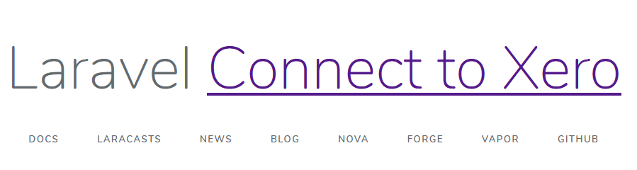

1. copy/paste the code below into 4 separate PHP files and substitute your **ClientId, ClientSecret and RedirectURI**

ref: https://github.com/XeroAPI/xero-php-oauth2

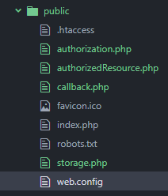

1. update Redirect Uri, ClientId， ClientSecret

'redirectUri' => 'http://localhost/project/Ossis/public/callback.php',

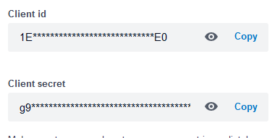

1. refresh Webpage. Click Connect to Xero



1. received error as below. Path issue.

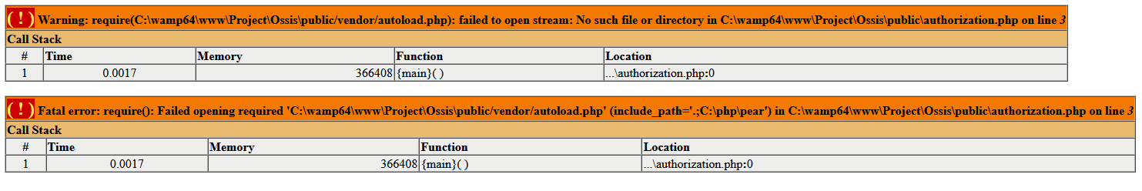

1. update autoload.php path on three files.

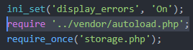

1. refresh page. (should see login page or select organisation if already logged in)

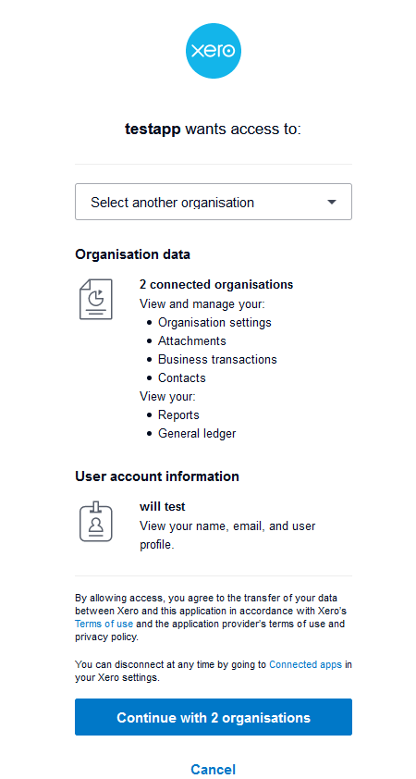

1. click continue receive below error:

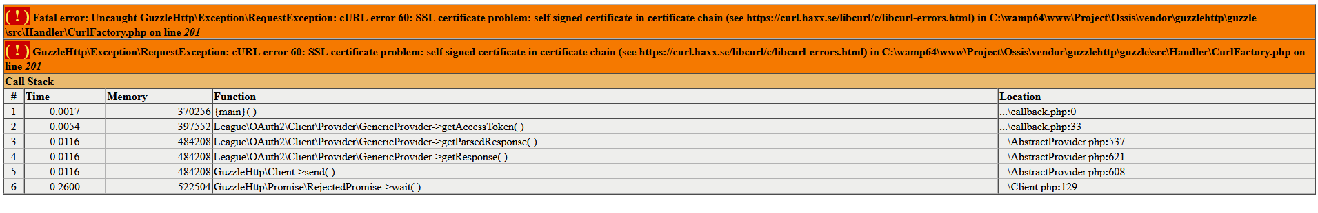

1. Googled find below info.

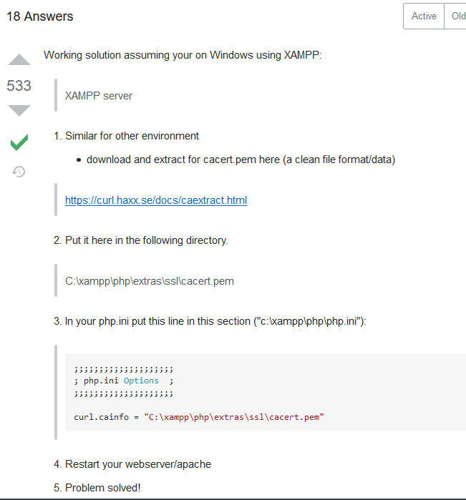

Ref: <https://stackoverflow.com/questions/29822686/curl-error-60-ssl-certificate-unable-to-get-local-issuer-certificate>

1. Download cacert and copy to local folder.

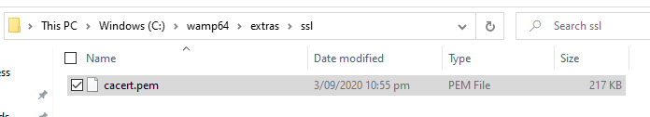

1. Update php ini file:

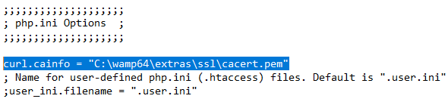

1. Restart Apache
2. Refresh webpage.

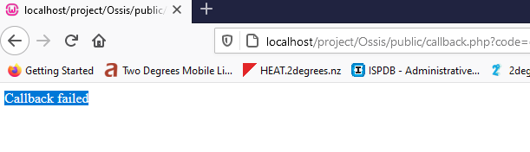

1. Didn’t find above issue. Re-try default page. Receive below error.



1. Remove “()” on line 156 from authorizedResource.php

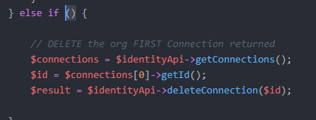

To:

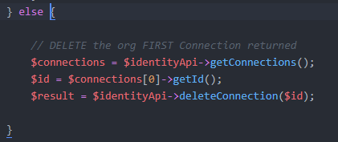

1. Refresh web page. Can receive below info.

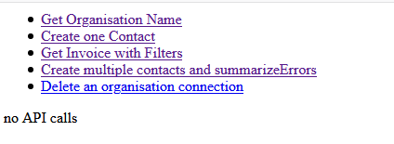

1. Can get Token from Callback.php

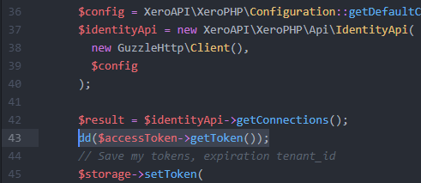

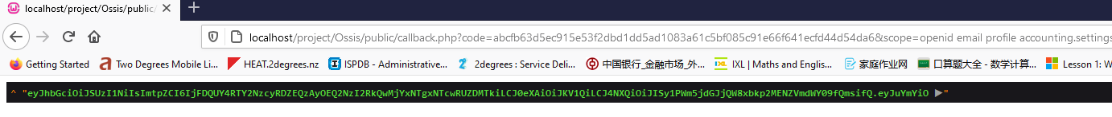

1. Can update **Scope** on Authorization.php

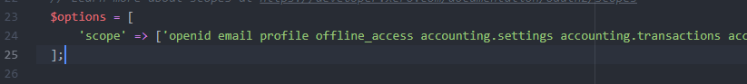

Testing:

php artisan make:controller OssisTestController

configure global variable config/global.php

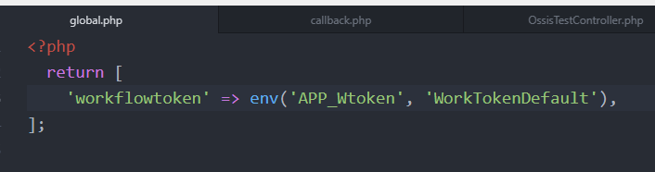

Set global variable callback.php

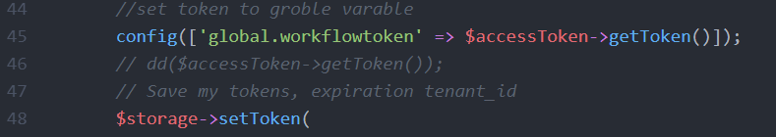

OssisTestController

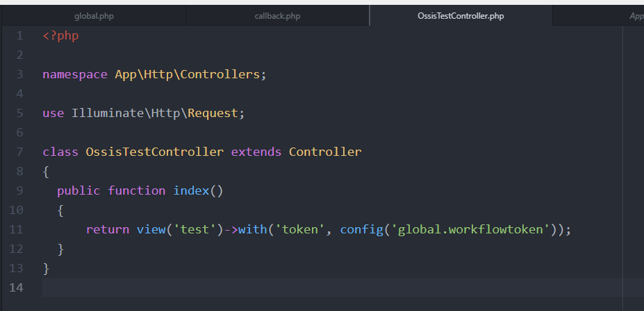

Route:

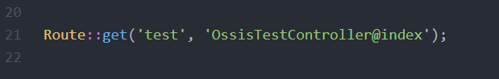

View:

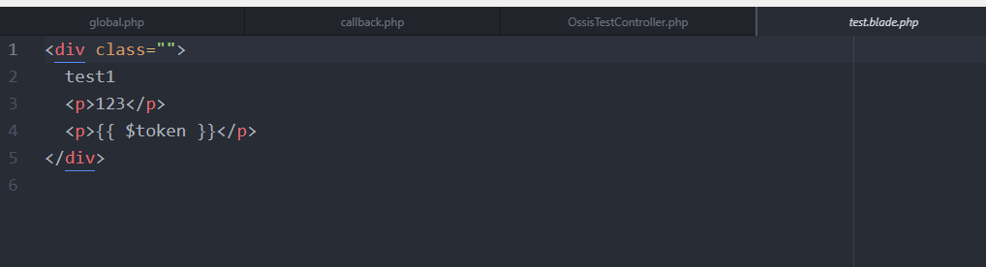

Install Guzzle:

composer require guzzlehttp/guzzle

install last version not working

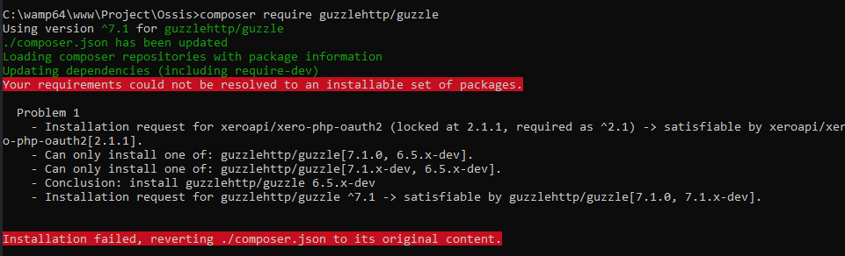

Install lower version

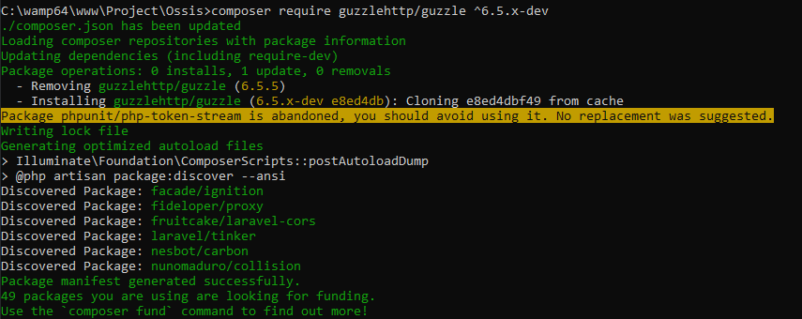

https://stackoverflow.com/questions/57579323/connecting-to-xero-oauth2-from-localhost-give-cors-erros

